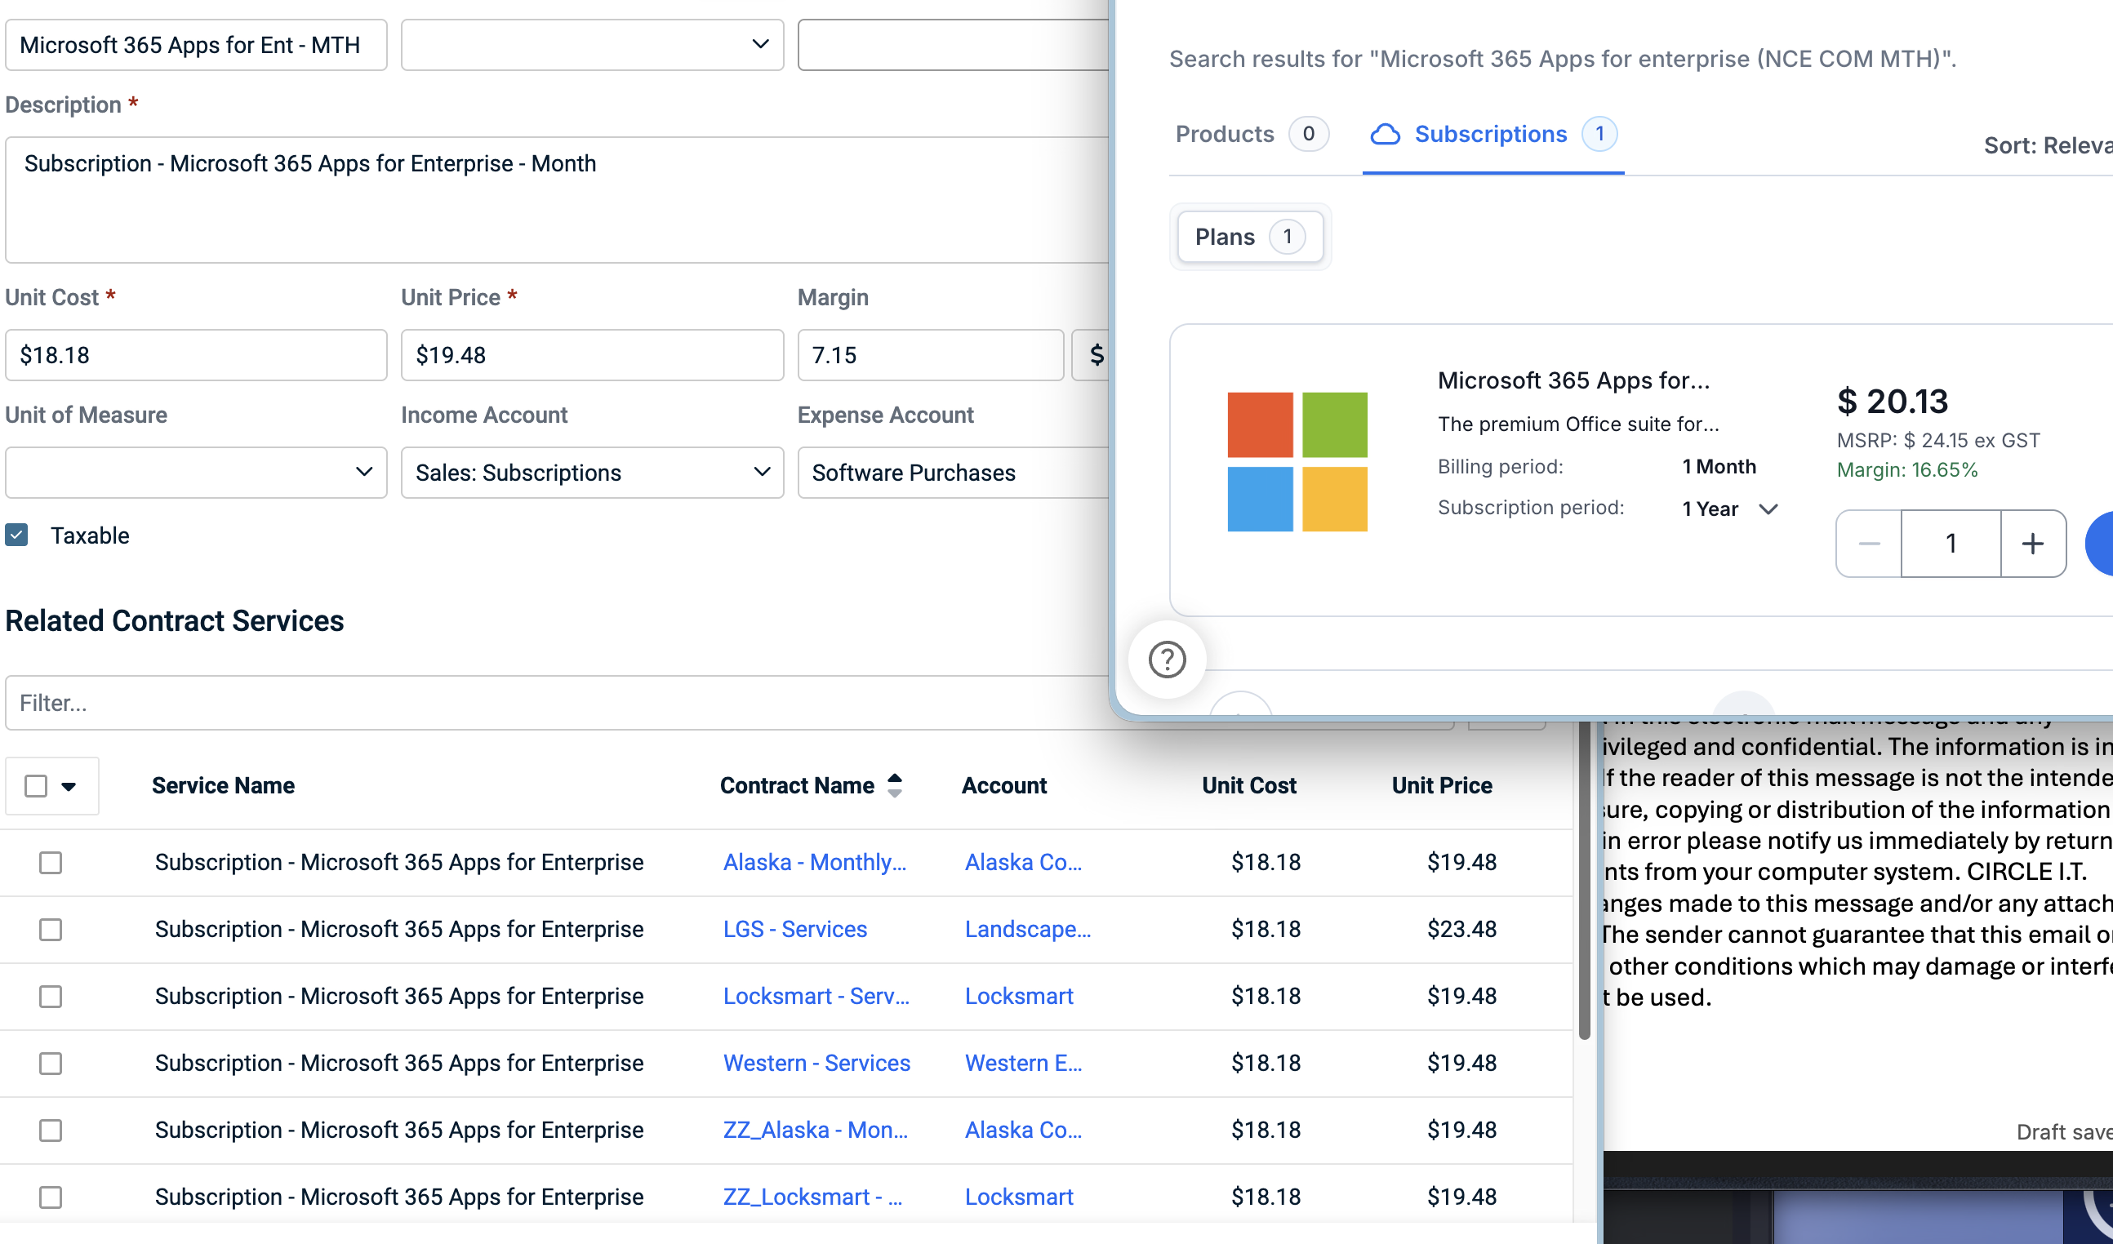
Alaska – 0
LGS – 2 – paying $9.34 too little – actually costs circle $1.30 a month
Locksmart - paying $42.03 too little – actually costs circle $5.85 a month
Western – 7 - paying $32.69 too little – actually costs circle $4.55 a month

Missing out on $84.06 profit but actually losing $11.70 a month

